SCT1-86E-RS
485 control speed and torque adjustable closed-loop drive

User Manual V1.0.5

Shenzhen GRMOT Technology Co., Ltd.

Table of contents
1. Product Introduction 1
1.1 Product Overview 1
1.2 Product Features 1
1.3 Application Areas 2
1.4 Naming Rules 2
2. Electrical, mechanical and environmental indicators 3
2.1 Mechanical Installation Drawings 3
2.2 Enhanced heat dissipation methods 3
2.3 Electrical Specifications 3
2.4 Usage Environment and Parameters 4
3.Driver Interface and Wiring Introduction 4
3.1 Interface Diagram 4
3.2 Interface Description 5
3.2.1 Encoder Interface 5
3.2.2 Motor control output interface 5
3.2.3 Power Input Interface 5
3.3 RS485 Communication InterfaceandIO control signal input interface 5
3.4Wiring requirements 6
4.Function Description 6
4.1 Panel Function Diagram 6
4.2 Digital Tube DisplayFunction 7
4.3 Torque and speed adjustment 7
4.4 Start-stop control 8
4.4.1 Panel switch controls start and stop 8
4.4.2 I/O signal control for start/stop 8
4.5 Special Functions 9
4.5.1 Adjustment of maximum output torque value 9
4.5.2 Maximum Output Speed ​​Adjustment 9
4.5.3 Other functional adjustments 9
4.6 Commonly usedFunction 11
4.6.1BlocktorqueOutput signal 11
5. MODBUS Communication Protocol and Functions 12
5.1 Basic Communication Parameters 12
5.2 MODBUS Register Address Definition 13
5.2.1 State Parameter Group (Read-only) 13
5.2.2 Common Parameter Group 1 (Read/Write) 14
5.2.3 Control Parameter Group (Read/Write) 15
5.2.4 Common parameter group 2 (read/write) 17
5.3 Commonly Used MODBUS Function Codes 18
5.3.1 Read Holding Register Command 0x03 18
5.3.2 Write to a single register command 0x06 19
5.3.3 Write to multiple registers command 0x10 19
5.4 Communication Error Codes 19
5.4.1 CRC check error 20
5.4.2 Function code sending error 20
5.4.3 Error reading invalid data address 21
5.4.4 Write data address out of range 21
5.4.5 Register Count Overflow 21
5.4.6 Function code illegal read/write data error 22
5.4.7 Data write limit exceeded in register 22
6. Power supply selection 23
7. Indicator lights and alarm indicators 24
8. Warranty and after-sales service 25
8.1 Warranty 25
8.1.1 Free Warranty Status 25
8.1.2 Cases not covered by warranty 25
8.2 Exchange 25
8.2.1 Product replacement due to malfunction 25
8.2.2 Replacement for non-product malfunctions 26
8.3 Returns 26
8.4 After-sales service 27
9. Version Revision History 27

Product Introduction

1.1 Product Overview
The SCT1-86E-RS is a newly launched speed- and torque-adjustable closed-loop stepper driver with 485 control by Green IoT Technology Co., Ltd. It integrates the MODBUS-RTU standard protocol specification, and users can set various parameters such as speed value, torque level value, speed mode, and relative position mode through the host computer debugging software, which greatly enriches the practical functions of the product and can meet the application needs of most occasions.
The panel features a 4-digit LED display.CanDisplays the set speed and torque values.Users can adjust the speed and torque values ​​via knobs or via 485 communication commands; they can control the motor to start and stop via the switch on the panel or via the RUN and DIR I/O input interfaces on the back of the driver; and they can also control the motor to start and stop by sending start commands via 485 communication.
Driver supply voltage rangeDC24V~70V, mainly matched with 86-base closed-loop motors, but can also drive 42~60-base closed-loop motors..

1.2 Product Features
● Compact design for easy installation
● New generation 32-bit ARM technology, offering excellent stability, strong compatibility, and high cost-effectiveness.
● Employs RS485 bus with isolation and supports standard MODBUS-RTU protocol.
●Supports speed mode, relative position mode, JOG+, JOG-
● The driver communication address is 0x01 by default. More addresses can be set via 485 communication or by using the function knob on the front panel.
● Compatible with closed-loop motors on bases of 42-86mm.Mainly matched with closed-loop motors based on 86 base.
● Equipped with a 4-digit digital display showing speed and torque rating.
● The speed and torque levels can be adjusted via the knob.
● It can be controlled via a 3-position 3-pin switch on the panel.The driver's rear I/O input interface and 485 communication command output are located on the back.Controlling motor start and stop
●Low vibration and low noise
●Features overvoltage and undervoltage alarm protection functions
●Input voltage range:DC24V~70V

1.3 Application Areas
Suitable for various small and medium-sized automated equipment and instruments, such as: intelligent logistics, textile industry, barrier gate industry, winding industry, etc.

1.4 Naming Rules
The naming conventions for driver models are as follows:
SCT1-86E-RS-
① ② ③ ④ ⑤ ⑥

Serial Number | meaning
① | Product series name; SCT: Speed ​​control type products;
② | Product series number; 1: Series number is 1;
③ | Matching motor base; 86: Primarily matches motors with 86 bases;
④ | Open-loop/closed-loop drive; E: closed-loop;
⑤ | Special function codes; RS: with 485 control;
⑥ | Design change code;

Electrical, mechanical and environmental indicators

2.1 Mechanical Installation Drawings
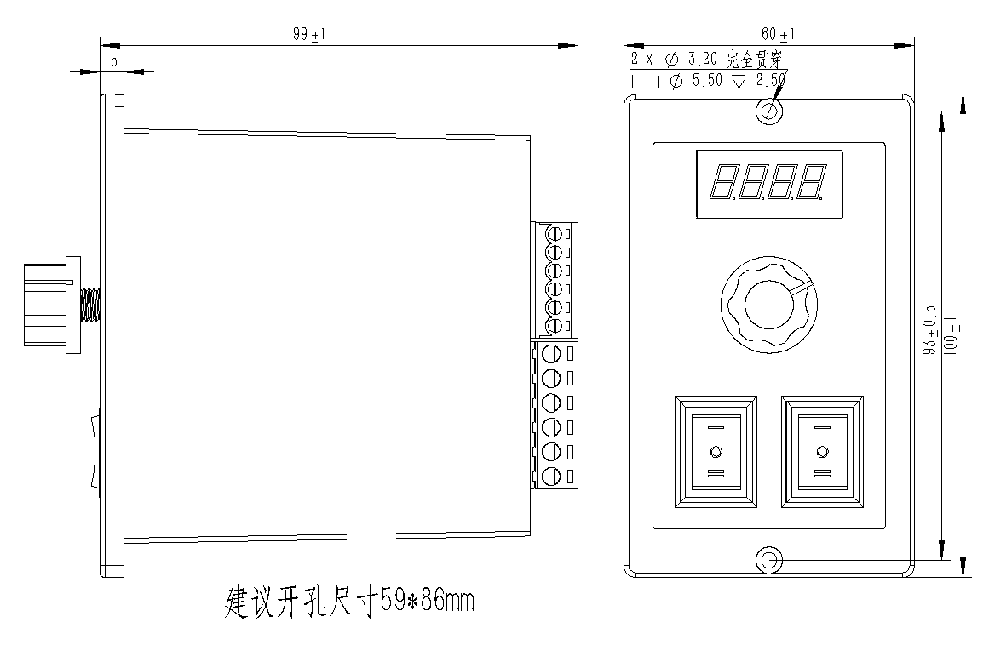
Figure 2.1 Installation dimensions (unit: mm)
Side mounting is recommended for better heat dissipation. When designing the installation dimensions, the size of the wiring terminals and the wiring should be considered.

2.2 Enhanced heat dissipation methods
- The reliable operating temperature of the drive is usually below 50℃, and the operating temperature of the motor is below 80℃.
- When installing the driver, strong air convection can be formed on the side of the driver; if necessary, a fan can be installed inside the machine near the driver to form air convection, assist in cooling the driver, and ensure that the driver operates within a reliable operating temperature range.

2.3 Electrical Specifications
illustrate | SCT1-86E-RS
illustrate | Minimum value | Typical value | Maximum value | unit
Input DC power supply voltage | twenty four | 48 | 70 | VDC
Insulation resistance | 50 |  |  | MΩ

2.4 Usage Environment and Parameters
Cooling method |  | Natural cooling, fan cooling
Usage Environment | occasion | Do not place near other heat-generating equipment. Avoid dust, oil mist, corrosive gases, high humidity, and areas with strong vibrations. Keep out of reach of flammable gases and conductive dust.
Usage Environment | temperature | 0-50℃
Usage Environment | humidity | 40-90%RH
Usage Environment | vibration | 10~55Hz/0.15mm
Storage temperature |  | -20℃~65℃

3.Driver Interface and Wiring Introduction

3.1 Interface Diagram
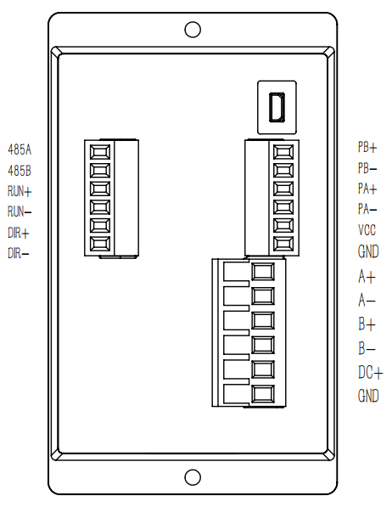

Figure 3.1 Schematic diagram of SCT1-86E-RS interface

3.2 Interface Description
The SCT1-86E-RS 485-controlled speed and torque adjustable closed-loop driver uses 5.08-6P terminal blocks for the power supply and motor interfaces, and 3.81-6P terminal blocks for the encoder interface. The 485 communication interface currently uses a wired connection. See the following sections for detailed interface definitions.

3.2.1 Encoder Interface
name | Function
PB+ | For the encoder's B-phase input interface, pay attention to the wiring sequence.
PB-
PA+ | For the encoder's A-phase input interface, pay attention to the wiring sequence.
PA-
VCC | The encoder is powered by a 5V power supply.
GND | The encoder is powered by a 5V power supply at the negative terminal.

3.2.2 Motor control output interface
name |  | color | illustrate | Function
Motor | A+ | red | Motor interface | For two-phase stepper motor wiring terminals, pay attention to the wiring sequence.
Motor | A- | blue | Motor interface
Motor | B+ | green | Motor interface
Motor | B- | black | Motor interface

3.2.3 Power Input Interface
name |  | illustrate | Function
VDC | DC+ | Power interface | Supports AC/DC power input  DC24V~70V
VDC | GND | Power interface | Supports AC/DC power input  DC24V~70V

3.3 RS485 Communication InterfaceandIO control signal input interface
The communication interface and IO control signal input interface of the SCT1-86E-RS 485 control speed and torque type closed-loop driver are located on the back of the driver, using a 3.81-6P terminal. The pin definitions are shown in the table below.
name | illustrate | Function
485A | RS485 communication interface | RS485 communication A-end
485B | RS485 communication interface | RS485 communication B-end
RUN+ | External I/O control signal interface | Upon receiving the start control signal, control the motor to rotate forward;  Supports 24V signal;
RUN- | External I/O control signal interface
DIR+ | External I/O control signal interface | Receive the reverse control signal to control the motor to reverse.  Supports 24V signal;
DIR- | External I/O control signal interface

3.4Wiring requirements
- The motor wires and encoder wires must be shielded to prevent interference signals from entering the encoder signal terminal, affecting the operating performance, and causing system instability and other malfunctions.
- If a power supply powers multiple drivers, they should be connected in parallel at the power supply point. A chain-like connection, where the power supply goes to one driver first and then to the next, is not allowed.
- It is strictly forbidden to plug or unplug the high-voltage terminals of the driver while it is powered on. Even when the motor is stopped, a large current still flows through the coil. Plug or unplug the terminals while they are powered on, which will cause a huge instantaneous induced electromotive force and burn out the driver.
- It is strictly forbidden to tin the wire ends before connecting them to the terminals, otherwise the terminals may overheat and be damaged due to increased contact resistance.
- The wire ends must not be exposed outside the terminals to prevent accidental short circuits that could damage the driver.

4.Function Description

4.1 Panel Function Diagram
The following is a schematic diagram of the panel functions of the SCT1-86E-RS 485 control speed and torque type closed-loop driver.
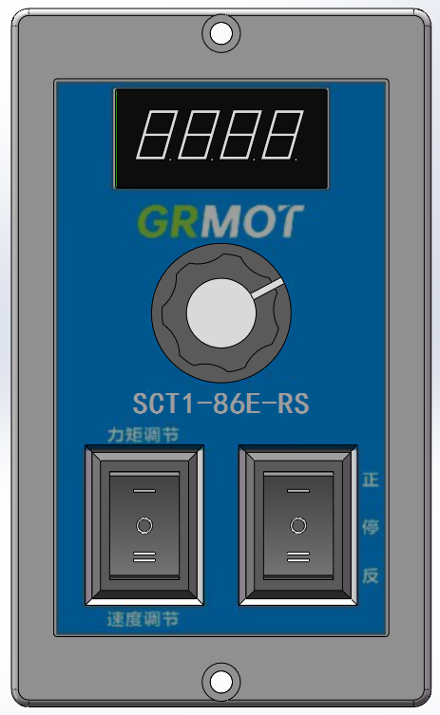

Figure 4.1 Functional diagram of SCT1-86E-RS panel

4.2 Digital Tube DisplayFunction
The speed and torque rating are displayed using a 4-digit LED display.As shown in the following figure.
Digital tube display example | meaning
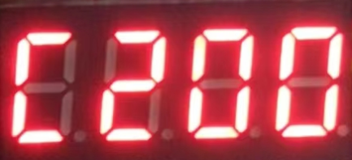 | The digital display shows 'C200', indicating that the current torque value is 200. At this time, the torque output value can be adjusted by the knob, with the default adjustment range being 0-200.
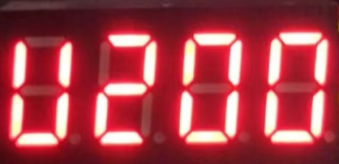 | The digital display shows 'U200', indicating that the current speed output value is 200 rev/min; at this time, the speed output can be adjusted by the knob, with the default adjustment range being 0-999 rev/min;
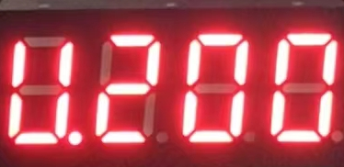 | The digital display shows 'U.200', indicating that the current speed is 200 rev/min, and rotating the knob is ineffective at this time and will not affect the set torque and speed values.
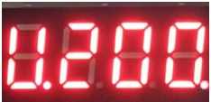 | When the panel direction control rocker switch is turned onThe decimal point of the fourth digit LED display lights up;

4.3 Torque and speed adjustment
The torque and speed setting ranges can be switched to the corresponding gear (torque adjustment or speed adjustment) using a 3-pin 3-speed switch, and then adjusted using a knob. The specific relationship is as follows:
Torque and speed regulation  Location of the switch | Knob adjustment value | describe | Remark
'I' | Adjusting the torque output value | Range: 0-200 | Torque and speed values ​​can also be adjusted via 485 communication. See details for further information.Section 5.2.3;
'II' | Adjust the output speed value | Range: 0-999, Unit: rev/min
'O' | Knob adjustment function is not working | -

4.4 Start-stop control

4.4.1 Panel switch controls start and stop
The motor's forward, reverse, and stop functions can be controlled via a 3-position switch on the front panel (Note: If the motor is running via a 485 controller, this switch will not control its operation). The control logic is shown in the table below:
Forward and reverse adjustment  Location of the switch | Motor motion status | describe | Remark
'I' | Forward | - | It can also be started and stopped via 485 communication. See details.Section 5.2.3;
'II' | Reversal | -
'O' | stop | It will eventually be in a released state, allowing users to rotate it without resistance.

4.4.2 I/O signal control for start/stop
The SCT1-86E-RS not only supports motor start/stop control via the start/stop switch on the front panel, but also connects to a PLC or control board output via two IO control signal interfaces on the back of the driver to control the motor's forward, reverse, and stop rotation. Its control logic is shown in the table below:
RUN signal | DIR signal | Motor motion status | describe
invalid | invalid | stop | It will eventually be in a released state, allowing users to rotate it without resistance.
efficient | invalid | Forward | -
invalid | efficient | Reversal | -
efficient | efficient | Reversal | -
Notice:
- When controlling the motor start and stop using this IO signal, it is necessary to ensure that the 3-position switch controlling the start and stop on the front of the drive panel is in the 'O' invalid state for the control to be effective.

4.5 Special Functions

4.5.1 Adjustment of maximum output torque value
When the torque and speed adjustment switch is in the 'I' position, press and hold the knob for 3 seconds. The digital display will then switch to the display shown in the image below. At this time, you can adjust the maximum value of the driver's output current using the knob. The default setting is 4000 mA, and the adjustable range is 0-6000 mA with a resolution of 100. After setting the desired maximum current value, press the knob switch once. The set current (i.e., torque) maximum value will be automatically saved, and the current torque setting value Cxxx will be displayed.(xxx is the torque setting value).
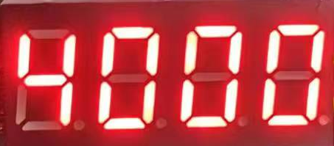
This upper limit can also be set via 485 communication; see section 5.2.4 for details.

4.5.2 Maximum Output Speed ​​Adjustment
When the torque and speed adjustment switch is in the 'II' position, press and hold the knob for 3 seconds. The digital display will then switch to the display shown in the image below. At this time, you can adjust the maximum speed of the driver using the knob. The default setting is 200, unit: rev/min, adjustable range is 0-3000, resolution is 1. After setting the desired maximum speed value, press the knob switch once to automatically save the set maximum speed value and display the current speed value Uxxx.(xxx is the rotational speed value).
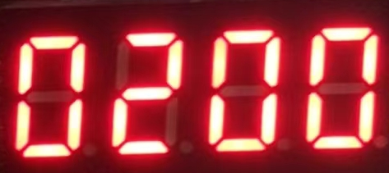

4.5.3 Other functional adjustments
When the torque and speed adjustment switches are in the 'O' position, press and hold the knob for 3 seconds, and the digital display will switch to the function display Pxxx (xxx is the function code) as shown in the figure below:
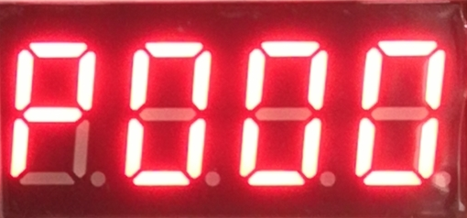
Currently, function code P000 is available.~P004The function can be selected using the knob. After selecting the desired function code, press the knob switch to enter the corresponding parameter adjustment interface. The specific descriptions of the function codes are shown in the table below:
Function code | Function Description | Detailed description
P000 | Select the compatible motor series number | There are four selectable values: 86, 57, 42, and 60, corresponding to four different motor series. The default setting is 86. After selecting the corresponding motor series, press the knob switch to automatically save the selection. The digital display will then show the current speed value U.xxx.(xxx is the rotational speed value);
P001 | Select the lock-up current ratio after shutdown | The setting range is 0~100, with a default value of 0. After setting the lock current ratio, pressing the knob switch will automatically save the set lock current ratio value, which will then be displayed on the digital tube.The current speed value U.xxx is displayed correctly.(xxx is the rotational speed value);
P002 | Set 485 communication address | The setting range is 0~999, with a default value of 1, indicating that the current driver's communication address is 1. After setting the desired address, pressing the knob switch will automatically save the set communication address, and then the digital tube will display the information.The current speed value U.xxx is displayed correctly.(xxx is the rotational speed value);
P003 | Set acceleration time | Set range 0~5000, the default value is1000; when setaccelerateThen, press the knob switch once, and the settings will be saved automatically.Acceleration timeSubsequently, the digital tubeThe current speed value U.xxx is displayed correctly.(xxx is the rotational speed value);
P004 | Set deceleration time | Set range 0~5000, the default value is500; when setslow downThen, press the knob switch once, and the settings will be saved automatically.deceleration timeSubsequently, the digital tubeThe current speed value U.xxx is displayed correctly.(xxx is the rotational speed value);

4.6 Commonly usedFunction

4.6.1BlocktorqueOutput signal
When the driver-controlled motor is completely stalled during operation, bit 9 of register 0x0008 will be set to 1, indicating that the driver is currently in a stall torque state. When the stall disappears, bit 9 of register 0x0008 will be set to 0. The specific function of each bit in register 0x0008 is shown in the table below:
Register address | project | illustrate | Set range  Note: Other values ​​are invalid. | default value
State parameter group 1 (read-only)
0x0008 | Input/output signal status query | Bit0~Bit7: Indicates the status of the input terminal;  Bit0: State of start/stop switch 'I';  Bit1: Start/stop switch 'II' state;  Bit2: Speed ​​and torque control switch 'I' state;  Bit3: Speed ​​and torque control switch 'II' state;  Bit4~Bit7: Reserved;  0: Invalid input level;  1: Input level is valid;  Bits 8-15: Indicate output status;  Bit8: Alarm output status;  Bit9: Stall torque has reached the signal output state;  Bits 10-15: Reserved;  0: Output level is invalid;  1: Output level is active; | (Read-only) | -

MODBUS Communication Protocol and Functions

5.1 Basic Communication Parameters
Table 5.1 Basic Communication Parameters
name | describe | Remark
Hardware interface | RS485 | RS232 not supported
Communication type | Asynchronous half-duplex | Communication between master and slave devices
baud rate | 9600 (default) | It can be set via DIP switch or host computer.
Communication Protocol | MODBUS-RTU | -
Function code | 0x03: Read single or multiple data  0x06: Writing a single data item  0x10: Write multiple data | -
Data character composition | Start bit: 1 bit; Data bits: 8 bits  Parity bit: None (default) / Odd / Even Stop bits: 1 bit (default) / 2 bits | Communication data format
Verification method | CRC16 | Low position first, high position second
Number of devices | 1 (default) | Higher settings

485 bus single message communication rate:
baud rate | Time from start of receiving to completion of sending (T1 (ms))
115200 | 3.49
38400 | 6.30
19200 | 10.46
9600 | 20.32
When multiple axes send messages continuously, there will be a PLC processing wait time T2 between messages. This value varies depending on the master station and the baud rate.

5.2 MODBUS Register Address Definition

5.2.1 State Parameter Group (Read-only)
Register address | project | illustrate | Set range  Note: Other values ​​are invalid. | default value
State parameter group 1 (read-only)
0x0000 | drive model | The drive model abbreviation, such as 10086 returned in the query. | (Read-only) | -
0x0001 | Driver version | Driver version | (Read-only) | -
0x0002 | Driver node number | Current communication slave node number | (Read-only) | -
0x0004 | Motor status  /Direction of movement | Bit0~Bit1: Indicates the status of the motor;  0: Stationary (locking shaft);  1: Exercise;  2: Release;  Bit2~Bit3: Indicates the direction of motor movement;  0: Positive direction;  1: In the opposite direction;  2: Invalid - Stopped state; | (Read-only) | -
0x0006 | Current error code | 0: Normal;  0x01～0x07: Error; | (Read-only) | -
0x0007 | Current error subcode | 0: Normal;  0x10～0x72: Error; | (Read-only) | -
0x0008 | Input/output signal status query | Bit0~Bit7: Indicates the status of the input terminal;  Bit0: State of start/stop switch 'I';  Bit1: Start/stop switch 'II' state;  Bit2: Speed ​​and torque control switch 'I' state;  Bit3: Speed ​​and torque control switch 'II' state;  Bit4~Bit7: Reserved;  0: Invalid input level;  1: Input level is valid;  Bits 8-15: Indicate output status;  Bit8: Alarm output status;  Bit9: Stall torque has reached the signal output state;  Bits 10-15: Reserved;  0: Output level is invalid;  1: Output level is active; | (Read-only) | -
0x000F | Current actual operating speed | The current actual operating speed value;  Unit: rev/min | (Read-only) | -
0x000D | Number of motor rotationslower 16 bits | The initial position after power-on is 0 revolutions, and the highest bit is the sign bit. A positive value indicates the number of revolutions in the positive direction, and a negative value indicates the number of revolutions in the negative direction.  Note: The cycle value will not be automatically saved when power is off. If you need this function, please refer to the description of registers 0x00A6 and 0x00A7.  unit:1rev | (Read-only) | -
0x000E | Number of motor rotationslower 16 bits |  | (Read-only) | -

5.2.2 Common Parameter Group 1 (Read/Write)
Register address | project | illustrate | Set range  Note: Other values ​​are invalid. | default value
Open-loop and closed-loop basic control common parameter group
0x0010 | Custom communication baud rate  Rate | 0:9600  1:14400  2:19200  3:38400  4:115200  5:128000  6:256000  Note: A power cycle is required for the changes to take effect. | 0～6  (Reading and writing) | 0
0x0011 | Serial port data format | 0: 8 bits of data, no parity, 1 stop bit;  1: 8-bit data, no parity, 2 stop bits;  2: 8-bit data, even parity, 1 stop bit;  3: 8-bit data, odd parity, 1 stop bit;  Note: A power cycle is required for the changes to take effect. | 0～3  (Reading and writing) | 0
0x0012 | Save parameter function | The corresponding bit position 1 can store the corresponding parameter group; the specific correspondence is as follows:  Bit0: Synchronous update function (0x0001), it is generally not recommended to enable this function;  0: EEPROM not updated synchronously;  1. Synchronize and update EEPROM;  Bit 15: Save all parameters (0x8000);  0: Do not save;  1: Save all 'read/write' attribute parameters;  Saving all parameters takes approximately 10 seconds. Please wait patiently for the saving to complete before performing other operations. You can also check this bit on the main site; if it is 0, it means the parameters were saved successfully. | 0～65535  (Reading and writing) | 0
0x0017 | Alarm clearing | 0: Invalid;  1: Alarm clearing; | 0～1  (Reading and writing) | 0
0x0018 | Parameters restored to factory settings  Place | 0: Invalid;  1: Restore factory settings; | 0～1  (Reading and writing) | 0

5.2.3 Control Parameter Group (Read/Write)
Register address | project | illustrate | Set range  Note: Other values ​​are invalid. | default value
Open-loop and closed-loop spontaneous pulse basic control parameter set
0x0070 | Button I/O control start/stop  Operating mode selection | Used for I/O control during start-up and shutdown.  For example, you can control the start and stop using the 3-position button on the panel; setting this position will allow you to run the corresponding mode.  0: Speed ​​Mode  1: Relative Position Mode | 0～1  (Reading and writing) | 0
0x0071 | Maximum speed | Set the maximum operating speed of the motor;  Unit: rev/min  Note: In speed mode, the direction of motor rotation is determined by the sign of the set value;  The following formula can be used to calculate negative values:  2^16 - abs (maximum speed value) | -3000~3000  (Reading and writing) | 200
0x0072 | Starting speed | Set the starting speed of the motor;  Unit: rev/min | 0-900  (Reading and writing) | 1
0x0073 | Acceleration time | Accelerate time;  Unit: ms | 0~5000  (Reading and writing) | 1000
0x0074 | deceleration time | Deceleration time;  Unit: ms | 0~5000  (Reading and writing) | 500
0x0076 | Relative position mode  Total pulse count (low byte) | In position mode, the total number of pulses for motor operation includes the total number of steps in the three stages of acceleration, constant speed, and deceleration; the highest bit represents the sign bit, a positive number indicates the number of pulses for forward movement, and a negative number indicates the number of pulses for reverse movement;  Note: If 100,000 pulses are set, the high-order setpoint value is 0x0001 and the low-order setpoint value is 0x86A0;  If -100000 pulses are set, the high-order setpoint value is 0xFFFE and the low-order setpoint value is 0x7960;  The number of pulses given in the opposite direction can be calculated using the following formula:  2^32 - abs (number of pulses given in the opposite direction) | -2147483648~  2147483648  (Reading and writing) | 10000
0x0077 | Relative position mode  Total pulse count (high byte) |  | -2147483648~  2147483648  (Reading and writing) | 10000
0x0078 | Startup command | The corresponding mode can be activated when the corresponding bit position is 1;  0x01: Speed ​​mode triggered;  0x02: Relative position mode triggered;  0x40: JOG+ sports;  0x80: JOG - Movement;  Note: The 3-position start/stop switch on the drive panel must be in the middle stop position before the motor can be controlled to start and stop through this register; | 0~255  (Reading and writing) | 0
0x0079 | Stop command | 0: Normal stop;  1: Emergency stop;  2: Run continuously at the set speed or along the planned trajectory until it stops; | 0~2  (Reading and writing) | 2

5.2.4 Common parameter group 2 (read/write)
Register address | project | illustrate | Set range  Note: Other values ​​are invalid. | default value
Open-loop and closed-loop spontaneous pulse basic control parameter set
0x0058 | Closed-loop maximum current setting | Set the maximum current limit for closed-loop operation;  Unit: mA; | 0~6000  (Reading and writing) | 4000
0x006D | Closed-loop motor locking force | Set the locking force when the closed-loop motor stops; the larger the value, the greater the locking force.  0: The motor will automatically release approximately 3 seconds after stopping;  1~100: After the machine stops, the motor always maintains a holding force; | 0~100  (Reading and writing) | 0
0x007D | Subdivision settings | Set the number of pulses per revolution in relative position mode;  Unit: Pul/Rev | 200~60000  (Reading and writing) | 10000
0x007F | Motor selection | Adapt to different motor parameter settings;  0:86 motor;  1:57 motor;  2:42 motor; | 0~2  (Reading and writing) | 0
0x00A1 | Driver node settings | The default driver address is 1; a new node can be set through this register.  Note:  (1) After making changes, you need to save the changes and power on again for the changes to take effect;  (2) The address can also be set by the function knob on the panel. For details on how to modify it, please refer to section 4.5.3. | 0-999  (Reading and writing) | 1
0x00A2 | Current torque value | Set the current output torque value of the motor; the adjustable range is 0-200.  If the set value is 100, then the torque output ratio is 100/200 = 50%; | 0~200  (Reading and writing) | 200
0x00A5 | Reset motor rotation count to zero | 0: No action;  1: Clear the current lap count; | 0~1  (Reading and writing) | 0
0x00A6 | Remember the lower 16 bits of the circle number | The highest bit is the sign bit. Users can write the number of revolutions before the last power failure into this register, and then synchronize the number of revolutions to registers 0x000D and 0x000E. | -536870~  536870  (Reading and writing) | 0
0x00A7 | lap count memoryhigh16-bit |  | -536870~  536870  (Reading and writing) | 0

5.3 Commonly Used MODBUS Function Codes

5.3.1 Read Holding Register Command 0x03
(1) The command to read a single register is as follows:
Master to Slave Data:
illustrate | Device address | Function code | Register address | Number of registers read | CRC check
message | 01 | 03 | 00 71 | 00 01 | D4 11
explain | The master sends a query command to the slave to the 'maximum speed (0x0071)' register.
Slave to Master Data:
illustrate | Device address | Function code | Number of bytes returned | Register value | CRC check
message | 01 | 03 | 02 | 00 C8 | B9 D2
explain | Data returned from slave device: Maximum speed 200 rev/min
- The command to read multiple registers is as follows:
Master to Slave Data:
illustrate | Device address | Function code | Register address | Number of registers read | CRC check
message | 01 | 03 | 00 71 | 00 04 | 14 12
explain | The host queries the slave for the four register values ​​starting with 'starting speed (0x0030)'.
Slave to Master Data:
illustrate | Device address | Function code | Number of bytes returned | Register value | CRC check
message | 01 | 03 | 08 | 00 C8 00 01  03 E8 01 F4 | 61 BC
explain | Data returned by the slave device: Maximum speed 200 rev/min, starting speed 1 rev/min, acceleration time 1000 ms, deceleration time 500 ms
Note: The maximum number of queries cannot exceed 16 registers.

5.3.2 Write to a single register command 0x06
(1) Write the set value to the register
Master to Slave Data:
illustrate | Device address | Function code | Register address | Write data | CRC check
message | 01 | 06 | 00 71 | 00 64 | D8 3A
explain | The master writes the value 100 to the slave's 'maximum speed (0x0071)' register.
Slave to Master Data:
illustrate | Device address | Function code | Register address | Write data | CRC check
message | 01 | 06 | 00 71 | 00 64 | D8 3A
explain | After receiving the instruction, the slave device returns the same instruction for confirmation.

5.3.3 Write to multiple registers command 0x10
Master to Slave Data:
illustrate | Device address | Function code | Starting address | Number of registers to write | Total bytes | Write data 1 | Write data 2 | CRC check
message | 01 | 10 | 00 71 | 00 02 | 04 | 00 64 | 00 01 | B5 58
explain | The master writes two registers to the slave, setting the 'starting speed (0x0030)' and 'acceleration time (0x0031)' registers respectively.
Slave to Master Data:
illustrate | Device address | Function code | Starting address | Number of registers to write | CRC check
message | 01 | 10 | 00 71 | 00 02 | 11 D3
explain | After receiving the instruction, the slave device returns the number of registers written for confirmation.

5.4 Communication Error Codes
The following table shows the exception codes for MODBUS communication in the 485 series:
Exception Code | name | meaning
01 | CRC check error | CRC check error.
02 | Function code sent error | The slave device receives function codes other than 0x03, 0x06, and 0x10.
03 | Invalid data address read error | The requested data address is an address that does not exist on the slave device.
04 | Write data address exceeded  Address range | The register address for which data is being written is outside the defined range of register addresses.
05 | Register count overflow | It can read data from a maximum of 16 addresses at a time.
06 | Function code illegal read/write data error | Function codes have three read/write attributes: read-only, write-only, and read/write. Operations on data that do not conform to the function code attributes will result in an error.
07 | Data write limit exceeded in register | The data written to the register exceeds its specified range.

5.4.1 CRC check error
As shown in the table below, if the host sends a command to read a data frame, and an error occurs during data transmission, and the CRC check value obtained by the slave device from calculating a data frame is not D8 3A, then the slave device returns an exception code 01.
Master to Slave Data:
illustrate | Device address | Function code | Register address | Number of registers read | CRC check
message | 01 | 03 | 00 71 | 00 64 | D8 3A
Slave to Master Data:
illustrate | Device address | Function code + 0x80 | Exception Code | CRC check
message | 01 | 83 | 01 | 80 F0

5.4.2 Function code sending error
As shown in the table below,If the function code requested by the host is not 0x03, 0x06, or 0x10, the slave returns exception code 02.
Master to Slave Data:
illustrate | Device address | Function code | Register address | Number of registers read | CRC check
message | 01 | 02 | 00 00 | 00 04 | 79 C9
Slave to Master Data:
illustrate | Device address | Function code + 0x80 | Exception Code | CRC check
message | 01 | 82 | 02 | 61 C1

5.4.3 Error reading invalid data address
As shown in the table below,If the address of the data requested by the host is invalid, i.e. does not exist, the slave returns exception code 03.
Master to Slave Data:
illustrate | Device address | Function code | Register address | Number of registers read | CRC check
message | 01 | 03 | 00 FF | 00 01 | B4 3A
Slave to Master Data:
illustrate | Device address | Function code + 0x80 | Exception Code | CRC check
message | 01 | 83 | 03 | 01 31

5.4.4 Write data address out of range
As shown in the table below,If the register address for the data written by the master is outside the defined range, the slave returns exception code 04.
Master to Slave Data:
illustrate | Device address | Function code | Register address | Write data | CRC check
message | 01 | 06 | FF 00 | 0B 00 | BE FE
Slave to Master Data:
illustrate | Device address | Function code + 0x80 | Exception Code | CRC check
message | 01 | 86 | 04 | 43 A3

5.4.5 Register Count Overflow
As shown in the table below,If the number of registers requested by the master exceeds the maximum range for a single read, the slave returns exception code 05.
Master to Slave Data:
illustrate | Device address | Function code | Register address | Number of registers read | CRC check
message | 01 | 03 | 00 71 | 00 20 | 14 09
The system read data from 32 addresses at once, exceeding the set range, and returned exception code 05.
Slave to Master Data:
illustrate | Device address | Function code + 0x80 | Exception Code | CRC check
message | 01 | 83 | 05 | 81 33

5.4.6 Function code illegal read/write data error
As shown in the table below,Function code read/write attributes are divided into three types: read-only, write-only, and read/write. For register operations that do not conform to the function code attributes...The slave device will then return exception code 06.
Master to Slave Data:
illustrate | Device address | Function code | Register address | Number of registers read | CRC check
message | 01 | 03 | 00 71 | 00 01 | D4 11
If register 0x0027 is a write-only address, a read operation on it will result in exception code 06.
Slave to Master Data:
illustrate | Device address | Function code + 0x80 | Exception Code | CRC check
message | 01 | 83 | 06 | C1 32

5.4.7 Data write limit exceeded in register
As shown in the table below,If the data written to the register exceeds its specified range...The slave device will then return exception code 07.
Master to Slave Data:
illustrate | Device address | Function code | Register address | Write data | CRC check
message | 01 | 06 | 00 73 | 27 10 | 62 2D
Slave to Master Data:
illustrate | Device address | Function code + 0x80 | Exception Code | CRC check
message | 01 | 86 | 07 | 03 A2

Power supply selection
The SCT1-86E-RS driver can operate normally as long as the power supply voltage is within the specified range. It is best to use a regulated DC switching power supply, and the output current range of the switching power supply should be set to its maximum. An unregulated DC power supply can also be used, but the peak voltage ripple after rectification should not exceed its specified maximum voltage. It is recommended that users use a DC voltage lower than the maximum voltage to avoid mains fluctuations exceeding the driver's operating voltage range.
If a regulated switching power supply is used, the output current range of the switching power supply should be set to its maximum.
Notice:
- When wiring, be careful to ensure that the positive and negative terminals of the power supply are not reversed;
- When wiring, pay attention to the position of the power interface and do not connect it to the motor port. After connecting, it is best to double-check that the connection is correct.
- It is best to use a regulated DC switching power supply;
- When using an unregulated DC power supply, the power supply current output capability should be greater than 60% of the driver's set current.
- When using a regulated DC switching power supply, the output current of the power supply should be greater than or equal to the operating current of the driver.
- To reduce costs, two or three drivers can share a single power supply, but the power supply should be sufficiently powerful.

Indicator lights and alarm indicators
The SCT1-86E-RS 485 speed and torque adjustable closed-loop driver displays the drive status via a digital tube. When the driver is powered on, the digital tube first displays four digits 0, followed by the current speed setting U.xxx (xxx is the speed value). If the torque and speed switch is in the 'I' or 'II' position, it will switch again to display Cxxx (xxx is the torque value) or Uxxx (xxx is the speed value).
When the driver malfunctions, the digital tube will display Erxx (xx is the alarm code), as shown in Table 6.1 below.
Table 7.1 Status Indicators of Digital Displays
Digital tube display | Fault Description | Handling measures
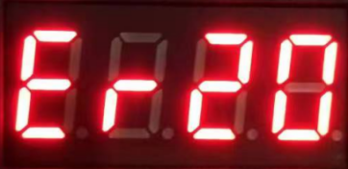 | Overvoltage alarm (It will not automatically return to normal.) | Check if the power supply is normal;  Check if the speeding and overloading are serious;
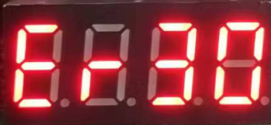 | Undervoltage alarmIt will not automatically return to normal.) | Check if the power supply is normal;

Warranty and after-sales service

8.1 Warranty

8.1.1 Free Warranty Status
Our company solemnly promises that all products purchased from us will be provided with one year of free repair service if they are damaged due to their own defects during use. The round-trip shipping costs will be shared equally by both parties.

8.1.2 Cases not covered by warranty
- The driver was damaged due to incorrect wiring by the customer.
- Exceeding the rated operating voltage can damage the driver.
- Connecting a DC-powered drive to an AC power source can damage the driver.
- The driver was damaged because the customer's site environment was extremely harsh, such as humid, extremely cold, or extremely hot, and the customer did not inform the company in advance.
- The customer disassembled the drive casing without authorization, or there were signs that the serial number had been torn off.
- The casing was visibly damaged or impacted 15 days after the customer confirmed receipt, resulting in damage to the driver.
- Unavoidable natural disasters, such as fires, earthquakes, tsunamis, typhoons, etc.;
In the above situations, our company will charge a certain repair cost fee after assessing the interests of all parties. In all other situations, repairs will be provided free of charge indefinitely.

8.2 Exchange

8.2.1 Product replacement due to malfunction
For any malfunctions in the new product itself, our company offers a three-month free replacement service.
Once our technical support staff confirms the problem is with the product itself, please send the product back to our company to avoid time and postage losses during the round trip. Customers must first send the faulty product back via express delivery or logistics. Upon receiving the product, our company will send a replacement to the customer as soon as possible.
Notice:All our products undergo rigorous testing and aging before leaving the warehouse, so malfunctions of new products are extremely rare. Please read the instruction manual carefully or consult our technical support personnel before operation, or have our technical support personnel remotely assist customers in operation.
- Please note the following points when exchanging goods:
- Please ensure the packaging is intact when returning the item to avoid damage during shipping;
- When exchanging goods, please ensure that all accessories are complete;
- Each driver should be individually packaged in its original outer box to avoid secondary damage to the product during transportation;
- If the drive is returned and confirmed to be not a product malfunction but rather due to customer negligence in operation, resulting in the customer mistakenly believing the drive to be faulty, our company will not bear the shipping costs (customer negligence includes: incorrect wiring leading to drive damage, faulty wiring leading to the mistaken belief that the drive is damaged, operational errors causing the drive to malfunction, etc.).

8.2.2 Replacement for non-product malfunctions
If a customer is dissatisfied with the appearance or function of the received product and wishes to replace it with a superior driver, they can apply for an exchange within one week of receiving the product. After verification, the product will be returned to the company. The company will replace the product with another one, provided the returned product is undamaged, all accessories are complete, and the packaging is in good condition. If there is a price difference in the replacement product, the customer will be responsible for the difference.
Note: Replaced products will no longer be eligible for non-product failure exchange services. All round-trip shipping costs and other expenses incurred for non-product failure exchange services will be borne by the customer!

8.3 Returns
Our company offers a 7-day return policy for products with quality issues. If you discover any quality problems with the product within 7 days of receiving it (based on the actual date of receipt by the customer), please contact our sales representative or technical support personnel in a timely manner. After our technical support personnel confirm that the product has quality issues, the customer should send the original complete product, its inner and outer packaging, accessories, and delivery note back to our company via express delivery or logistics.
If, after our company has inspected and confirmed that there are no errors, the customer still insists on returning the goods, the customer shall bear all round-trip shipping costs and all other expenses incurred as a result.
- Please note the following points when returning goods:
(1) Please contact the relevant department of our company before proceeding with the refund process;
(2) The product must be brand new and in its original packaging. Please send it back to our company by express delivery or logistics.
(3) We will not accept complaints about product damage, missing accessories, or other issues caused by the customer.

8.4 After-sales service
If you require after-sales service support while using this product, please contact our company immediately.
Nationwide toll-free service hotline: 0755-23206995;
Website: http://www.grmot.com//
Technical support hotline: 18576758897 (Mr. Xie), 17666115681 (Mr. Tuo);
Service hours: Monday to Friday, 8:30-17:30 (excluding national statutory holidays).

Version Revision History
Version number | illustrate | Modify deadline | Prepared by/Reviewed by
V1.0.0 | Initial version; | August 14, 2024 | TCJ/XH
V1.0.1 | (1) Minor revisions to the product feature description item in section 1.2;  (2) Optimize the descriptions of statements in sections 4.3, 4.4, 4.5.1, and 4.5.3;  (3) Section 5.2.3 describes the function description of the register;  (4) Add section 5.2.4; | August 16, 2024 | TCJ/XH
V1.0.2 | - The torque percentage has been changed to a torque rating value.  - In section 4.5.3, the table on page P001 details the addition of 60 parameters for the motor.  - Section 5.2.1 adds a stall-in-position output register 0x0008 and a current actual running speed register 0x000F;  - Added Chapter 4.6; | October 30, 2024 | TCJ, JQ/XH
V1.0.3 | (1) Add register 0x006D in section 5.2.4; | 2024.11.12 | TCJ/XH
V1.0.4 | - Sections 1.1, 1.2, and 3.3 have been optimized by adding descriptions of the start/stop function controlled by IO input signals;  - Section 4.4.2 has been added;  - The interface diagram in section 3.1 has been modified; | December 2024.24 | TCJ/XH
V1.0.5 | - Section 4.2 adds a decimal point function to the digital tube display;  - Section 4.5.3 adds acceleration and deceleration settings;  - Add registers 0x000D, 0x000E, 0x00A5, 0x00A6, and 0x00A7 related to the lap count function in sections 5.2.1 and 5.2.4; | October 7, 2025 | TCJ/XH

